**DB STRUCTURE**

Borrowers Information is divided into 4 tables. They are:-

1. Borrower
2. Financial_Details
3. Loan_Details
4. Property_Details

The Structure of the 4 tables is shown below:

**Borrower**

**Add: co-borrower info to this table**

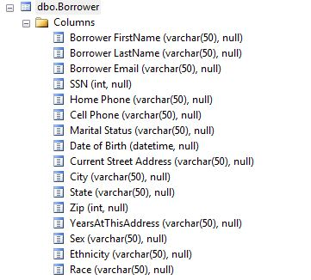

**Financial_Details:**

**Remove**

**purpose of loan, property usage, loan amount, purchase price, number of units**

**From this table.**

Marital Status 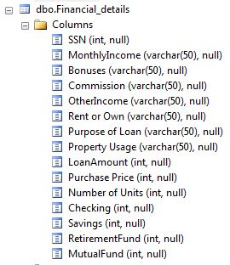p

**Loan_Details:**

**Loan Id should be primary key and property id and SSN should be a foreign keys**

**Remove property usage, co-borrower info, realestate agent info**

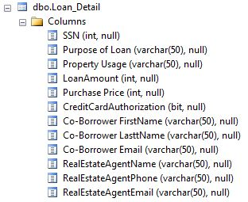

**Property _Detail**

**Make property id as primary key and SSN as foreignkeys**

**Add realestate agent info to this table**

